American International University-Bangladesh (AIUB)
Introduction to Database
Midterm Lab Tasks-01
- Write a query to display the name, department number for all employees.
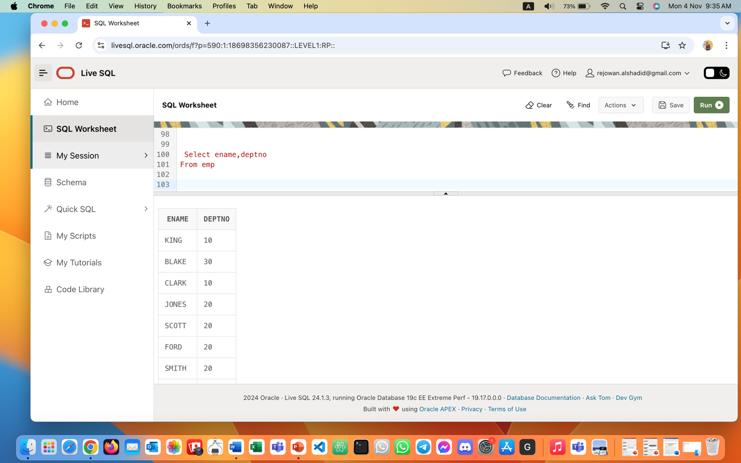
- Create a unique listing of all jobs that are in department 30.
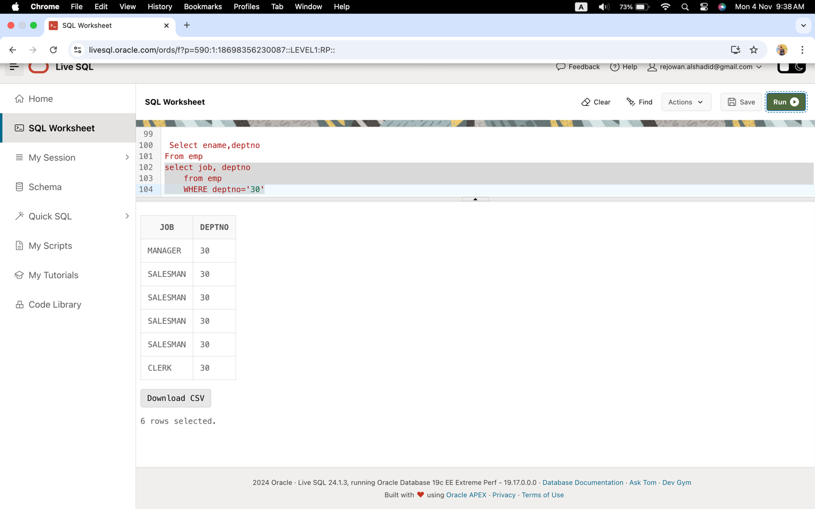
- Include the location of department 30 in the output.
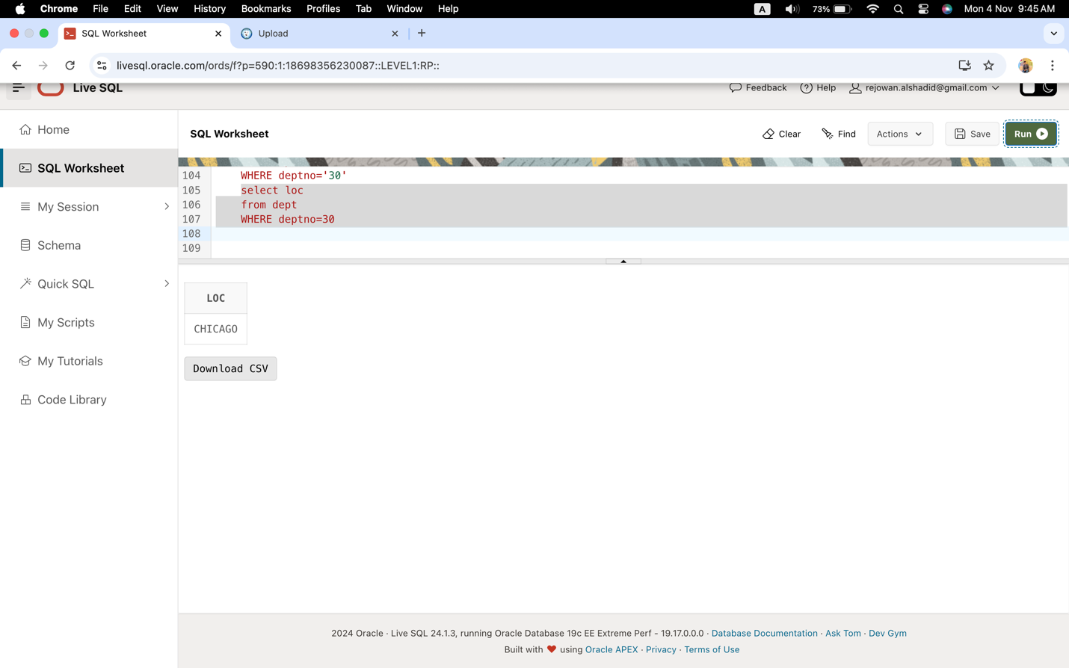
- Write a query to display the employee’s name, employee no of all employees who earn a commission.
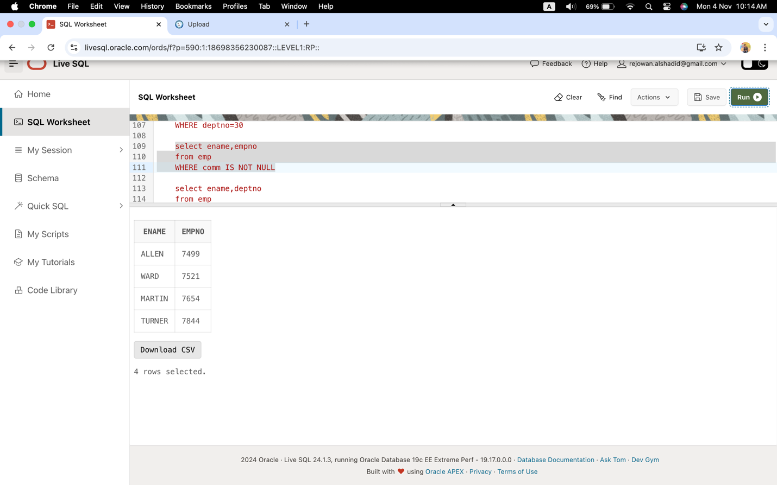
- Display the employee’s name and department no for all employees who have an A in their name.
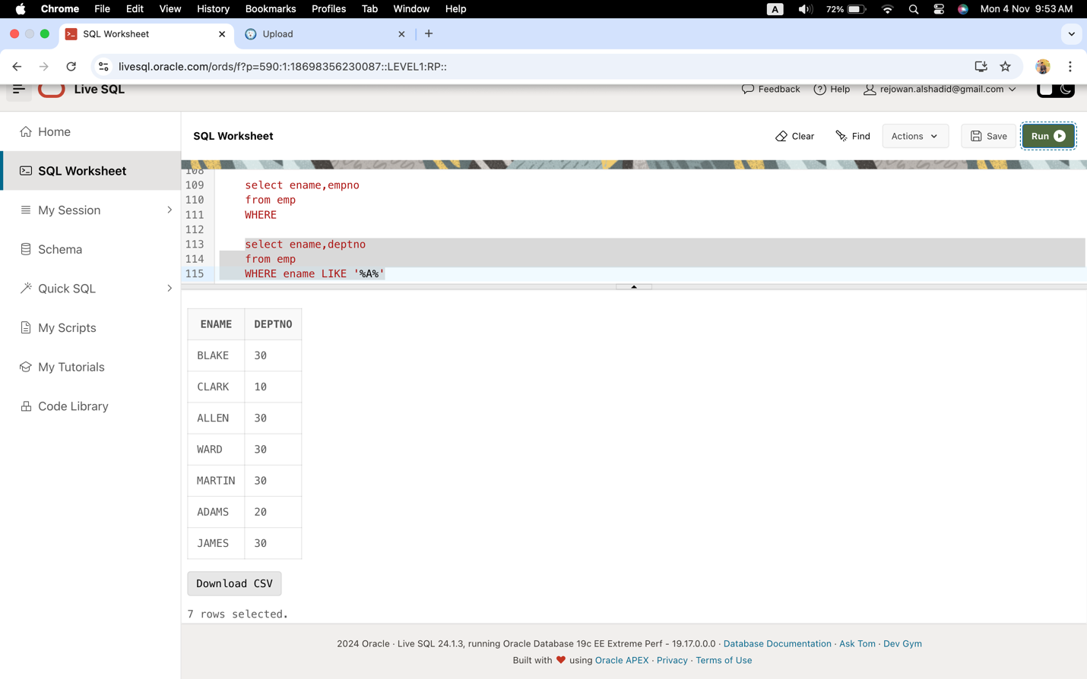
- Create a query to display the name and salary of employees earning more than $2850.
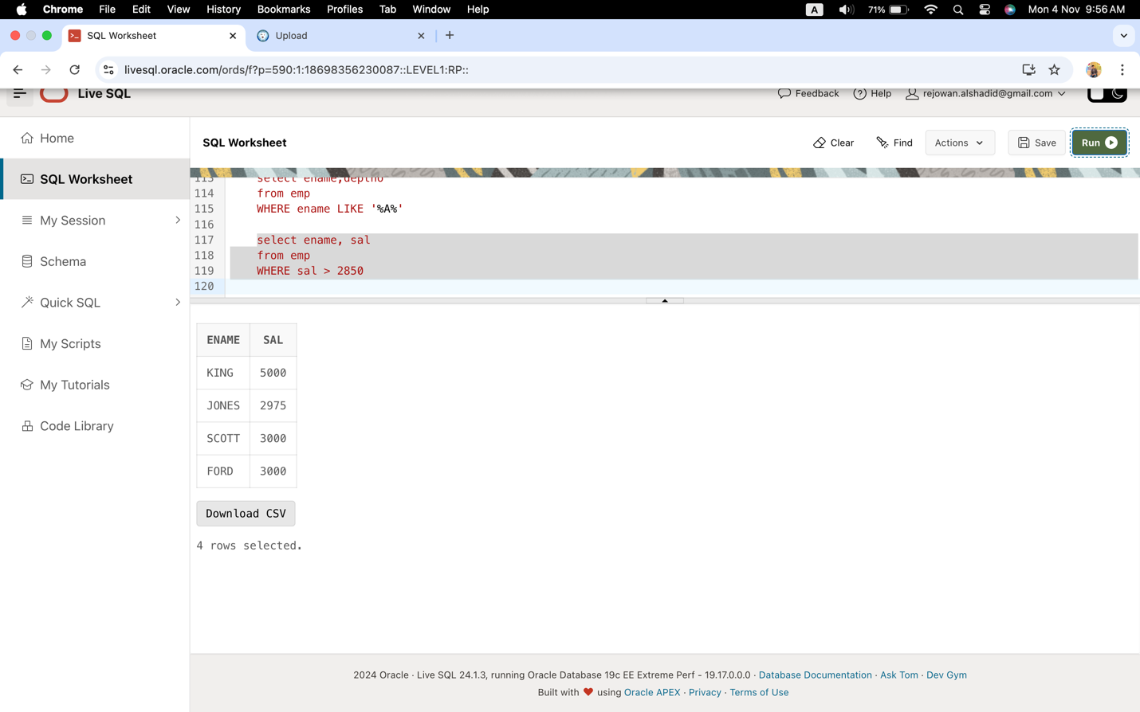
- Create a query to display the employee’s name and department number for employee number 7566.
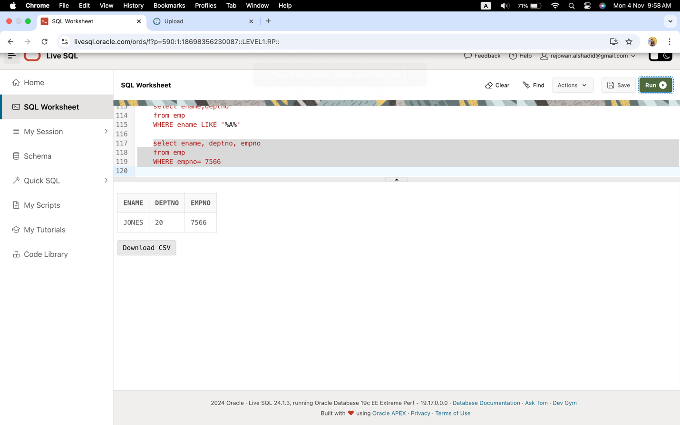
- Display the employee’s name, job, and start date of employees hired between February 20, 1981, and May 1, 1981. Order the query in ascending order by start date.
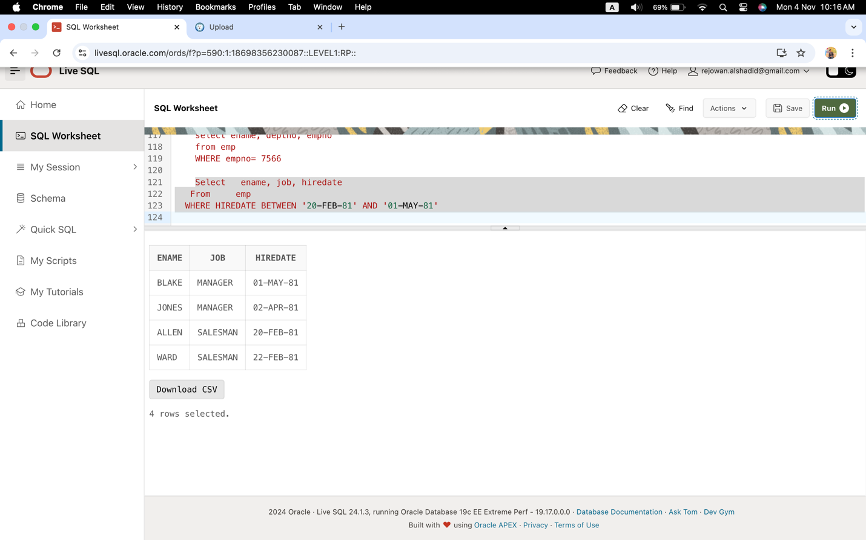
- Display the employee’s name and department number of all employees in departments 10 and 30 in alphabetical order by name.
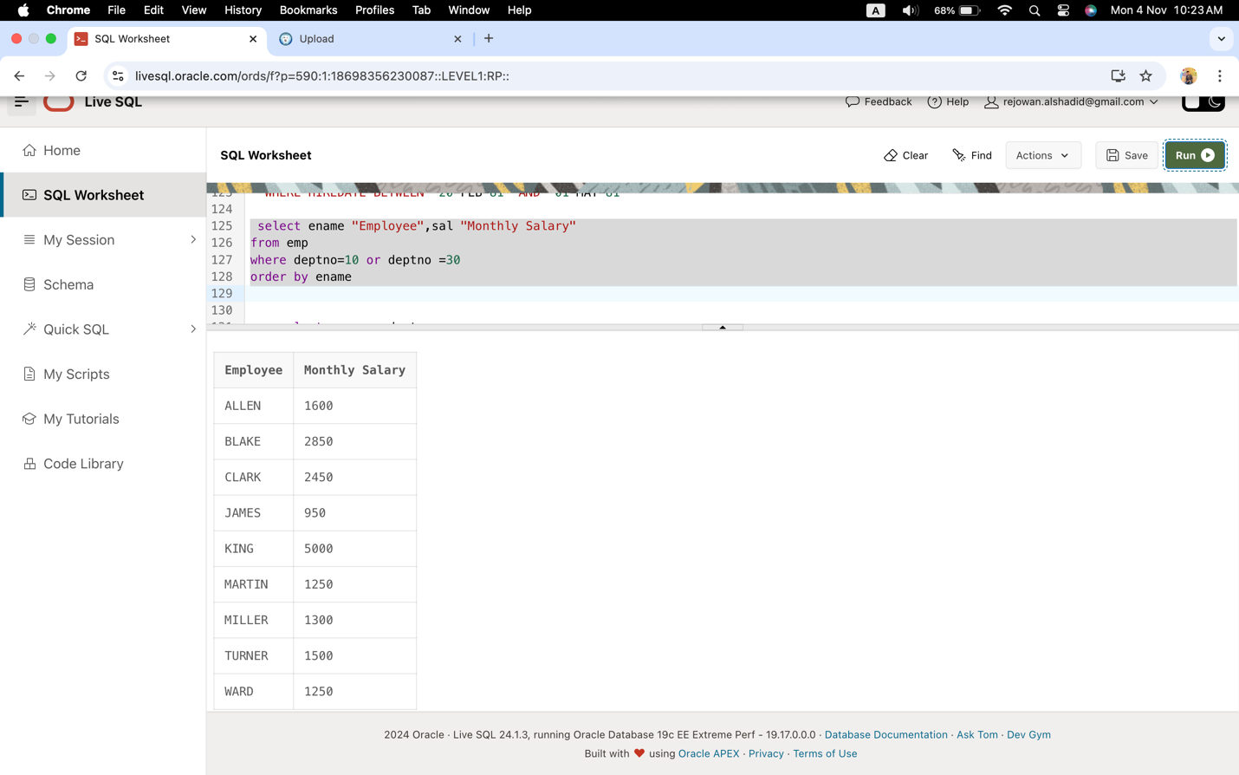
- Write a query to list the name and salary of employees who earn more than $1500 and are in department 10 or 30. Label the columns Employee and Monthly Salary, respectively.
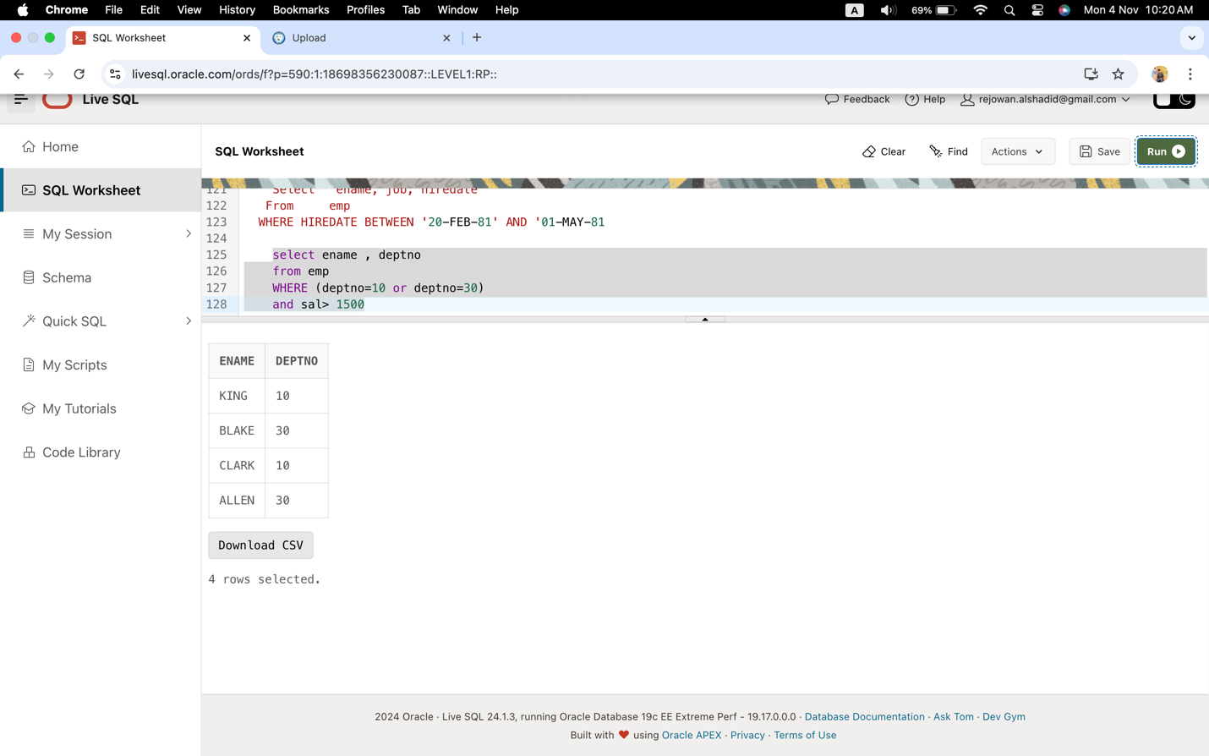
- Display the name and hire date of every employee who was hired in 1982.
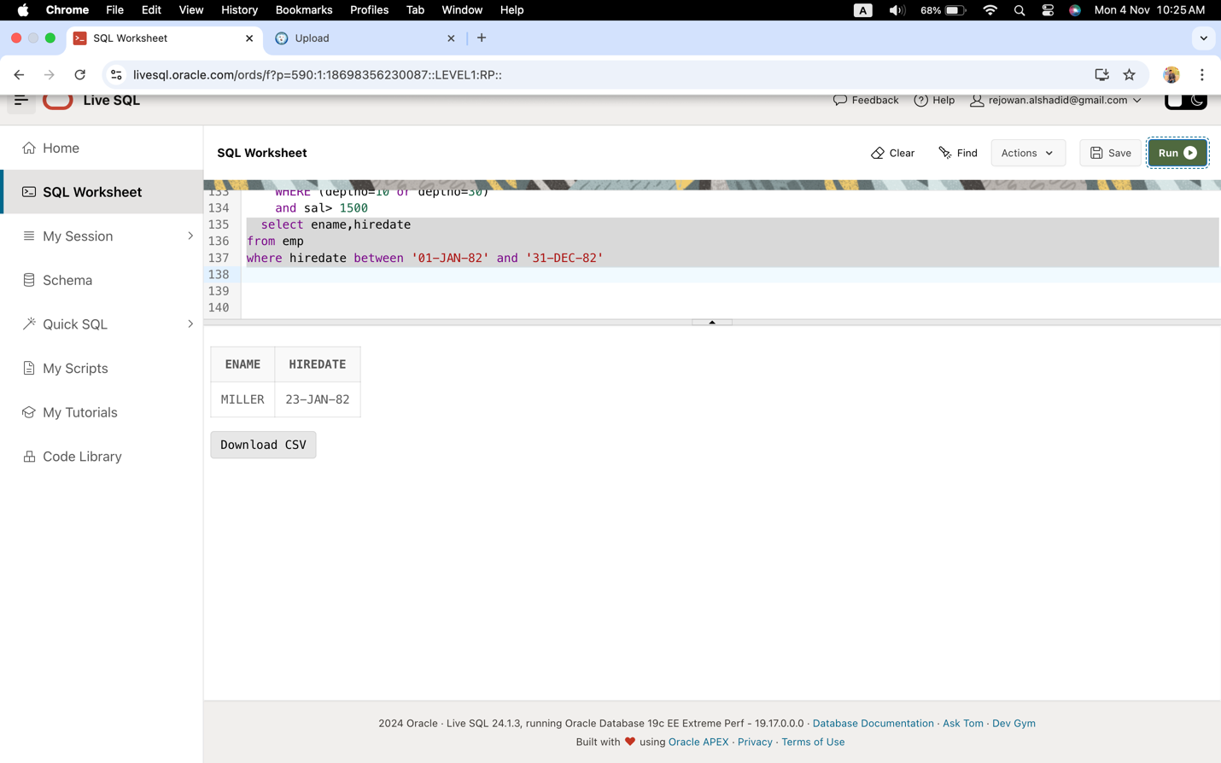
- Display the name and job title of all employees who do not have a manager.
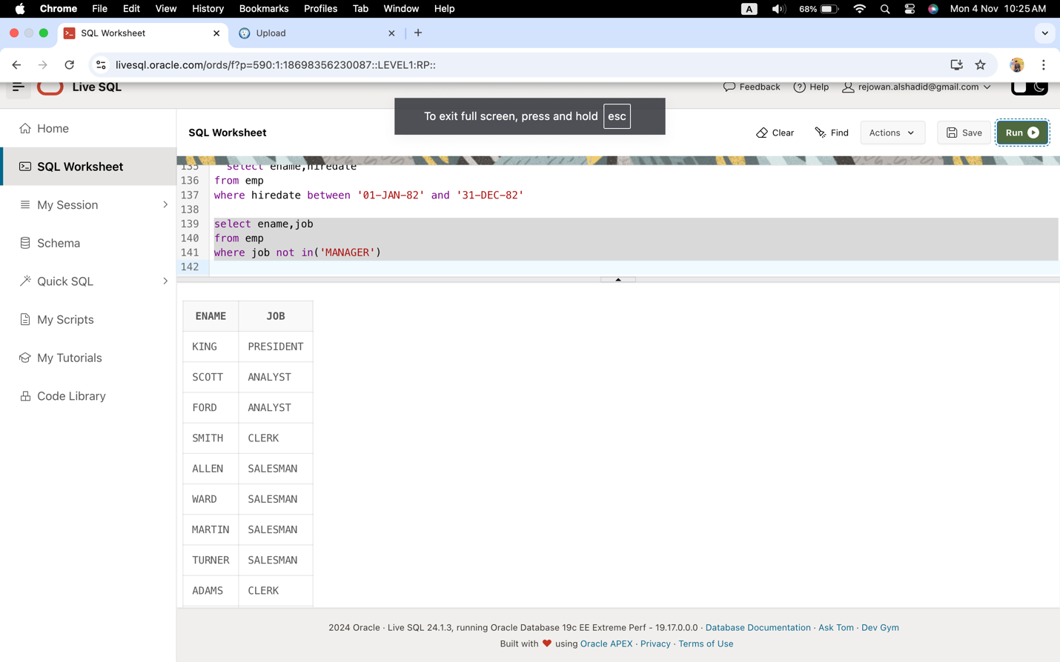
- Display the name, salary, and commission for all employees who earn commissions. Sort data in descending order of salary and commissions.
